ASSIGNMENT – 2.1

HEMANTH THOTA
2303A151040

Task 1: Statistical Summary for Survey Data
❖ Scenario:
You are a data analyst intern working with survey responses stored as
numerical lists.
❖ Task:
Use Google Gemini in Colab to generate a Python function that reads a list
of numbers and calculates the mean, minimum, and maximum values.
❖ Expected Output:
➢ Correct Python function
➢ Output shown in Colab
➢ Screenshot of Gemini prompt and result

PROMPTINGS:
#write a program to calculate mean.minimum and maximum of a list of numbers
CODE:
#write a program to calculate mean.minimum and maximum of a list of numbers
def calculate_mean_min_max(numbers):
mean = sum(numbers) / len(numbers)
minimum = min(numbers)
maximum = max(numbers)
return mean, minimum, maximum
if __name__ == "__main__":
input_numbers = list(map(int, input("Enter numbers separated by spaces: ").split()))
mean, minimum, maximum = calculate_mean_min_max(input_numbers)
print(f"Mean: {mean}, Minimum: {minimum}, Maximum: {maximum}")
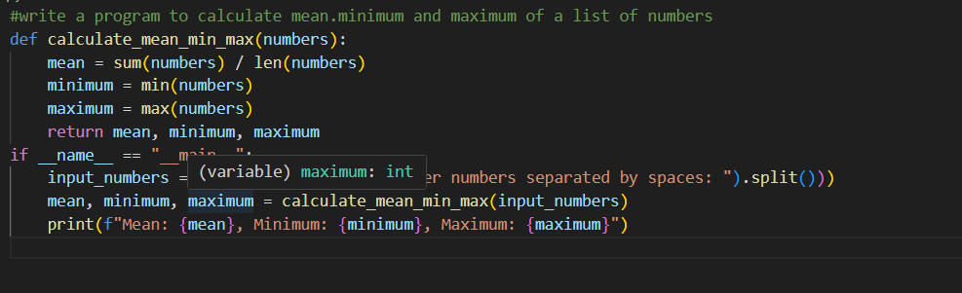
OUTPUT:
Task 2: Armstrong Number – AI Comparison
❖ Scenario:
You are evaluating AI tools for numeric validation logic.
❖ Task:
Generate an Armstrong number checker using Gemini and GitHub
Copilot.
Compare their outputs, logic style, and clarity.
❖ Expected Output:
➢ Side-by-side comparison table
➢ Screenshots of prompts and generated code
PROMPTING:
#write a progarm for amstrong number
CODE:
#write a progarm for amstrong number
def is_armstrong_number(number):
num_str = str(number)
num_digits = len(num_str)
sum_of_powers = sum(int(digit) ** num_digits for digit in num_str)
return sum_of_powers == number
if __name__ == "__main__":
input_number = int(input("Enter a number: "))
if is_armstrong_number(input_number):
print(f"{input_number} is an Armstrong number.")
else:
print(f"{input_number} is not an Armstrong number.")
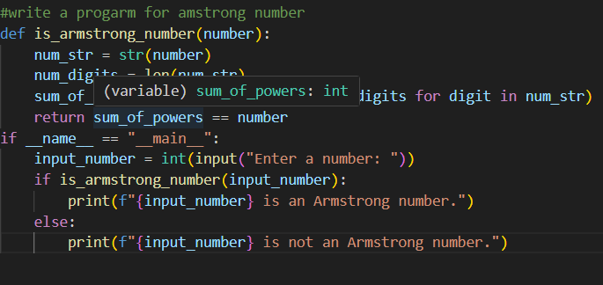
OUTPUT:
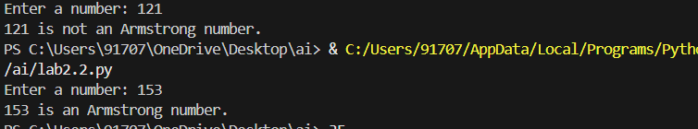
Task 3: Leap Year Validation Using Cursor AI
❖ Scenario:
You are validating a calendar module for a backend system.
❖ Task:
Use Cursor AI to generate a Python program that checks whether a given
year is a leap year.
Use at least two different prompts and observe changes in code.
❖ Expected Output:
➢ Two versions of code
➢ Sample inputs/outputs
➢ Brief comparison
PROMPTING:
#write a program to validate a leap year or not
CODE:
#write a program to validate a leap year or not
def is_leap_year(year):
if (year % 4 == 0 and year % 100 != 0) or (year % 400 == 0):
return True
else:
return False
if __name__ == "__main__":
input_year = int(input("Enter a year: "))
if is_leap_year(input_year):
print(f"{input_year} is a leap year.")
else:
print(f"{input_year} is not a leap year.")

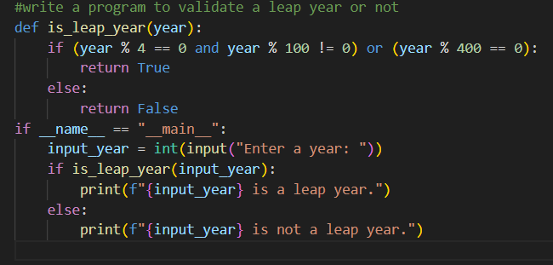
OUTPUT:
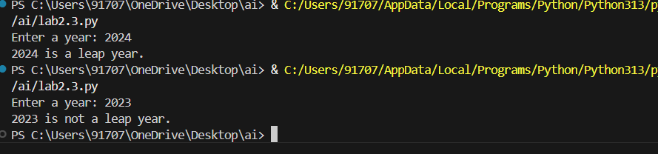
Student Logic + AI Refactoring (Odd/Even Sum)
❖ Scenario:
Company policy requires developers to write logic before using AI.
❖ Task:
Write a Python program that calculates the sum of odd and even numbers
in a tuple, then refactor it using any AI tool.
❖ Expected Output:
➢ Original code
➢ Refactored code
➢ Explanation of improvements
PROMPTING:
#write a program to write sum of odd and even numbers in a tuple
CODE:
#write a program to write sum of odd and even numbers in a tuple
def sum_odd_even_in_tuple(numbers):
odd_sum = sum(x for x in numbers if x % 2 != 0)
even_sum = sum(x for x in numbers if x % 2 == 0)
return odd_sum, even_sum

if __name__ == "__main__":
input_tuple = tuple(map(int, input("Enter numbers separated by space: ").split()))
odd_sum, even_sum = sum_odd_even_in_tuple(input_tuple)
print(f"Sum of odd numbers: {odd_sum}")
print(f"Sum of even numbers: {even_sum}")

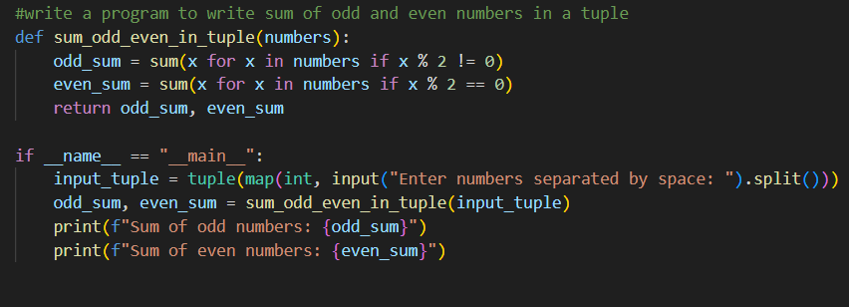
OUTPUT:
